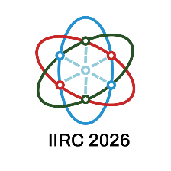

**Insight International Research Conference 2026 (IIRC2026)**

**on**

**“Trends in Sustainable Technology: Opportunities and Challenges”**

**DECLARATION BY AUTHOR(S)**

* I / We the undersigned declare that the abstract titled ……………………………………

………………………………………………………………………………………………………….

has not been presented or published elsewhere in the current form.

* I / We further confirm that the abstract includes work done by me / all of us and I / We have read the abstract.
* I / We also confirm that this abstract is devoid of any plagiarism, self-plagiarism or use of AI in developing this abstract.
* Further, I / We declare that I / We have not omitted any other person who was involved in this study.
* I / We also agreed collectively on the order of the authorship.
* On behalf of me / us, the corresponding author will communicate with the conference organizers.
* I / We also agree that one of the authors will take the responsibility of presenting the paper at the Conference.

|  |  |  |  |
| --- | --- | --- | --- |
|  | **Name** | **Signature** | **Date** |
| **Author 1** |  |  |  |
| **Author 2** |  |  |  |
| **Author 3** |  |  |  |
| **Author 4** |  |  |  |

Add more rows, if required.

**Note:** Email the completed declaration form to **secretary-iirc@insight.edu.lk** once you submit the paper via the conference management system. The submission **will not be processed** **until we receive the declaration form**.